**AWS Assignment**

1. List out the types of instance base on the pricing model and write a brief about your understanding about it.  
   **Amazon EC2 :** Amazon Elastic Compute Cloud (Amazon EC2) is a web service that provides secure, resizable compute capacity in the cloud.

It provides a pricing model that helps us skip upfront costs and problems of buying and setting up hardware. Instead, we can use a pay-as-you-go system, paying only for what we use during a month.

**Types of Instances :**

1. **On demand pricing :**

* Pay for compute capacity per hour or per second .
* This frees us from the costs and complexities of planning, purchasing, and maintaining hardware.
* On Demand Instances are best used for short-term workloads.
* It requires no upfront costs or minimum amount on the purchase.
* The instances run until you stop them.
* We pay for what we use.

1. **Spot Instances :**

* This pricing model is best for workloads with flexible start and end times, which can take interruptions.
* Spot instances can give up to a 90% cost savings.
* The reason behind the discount is that AWS can optimize its capacity, giving us better prices.
* Billing method : Per-hour or per-second.
* Pricing fluctuates based on supply and demand.

1. **Reserved Instances :**

* The Reserved Instances are used to reserve instances for an agreed period.
* Discount of up to 75% compared to On-Demand Instances when we commit to a 1 or 3-year term.
* Billing method : Per - hour
* The options are for 1-year or 3-years. The latter one gives the highest discount.

1. **Dedicated Hosts :**

* Dedicated hosts are physical servers fully dedicated to us .
* We can use our existing VM software licenses.
* The Dedicated Host is the most expensive model.
* Billing method : Per - hour

1. **Savings Plan :**

* The savings plan is a commitment for usage over a 1-year or 3-year term.
* Committing to a period gives a discounted price.
* If we surpass the budget, cost goes to normal (on-demand) prices.

1. Host a static website in S3.

Step 1: Creating a Bucket

Step 2: **Block Public Access Settings:** You disable blocking public access to allow anyone to view the files, as S3 buckets are private by default.

Step 3: Now upload code files in the bucket .

Step 4: **Make Objects Public:** This step grants public read access to the individual files, ensuring that anyone can access them.

Step 5: **Copy Object URL:** The URL links to the file you just uploaded, which is used to access your website.

Step 6: **Test the Website:** By pasting the URL, you can verify that your website is now live and accessible to the public.

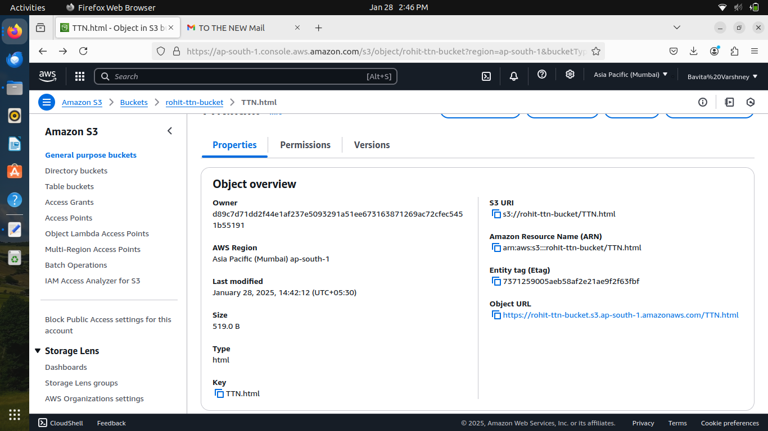

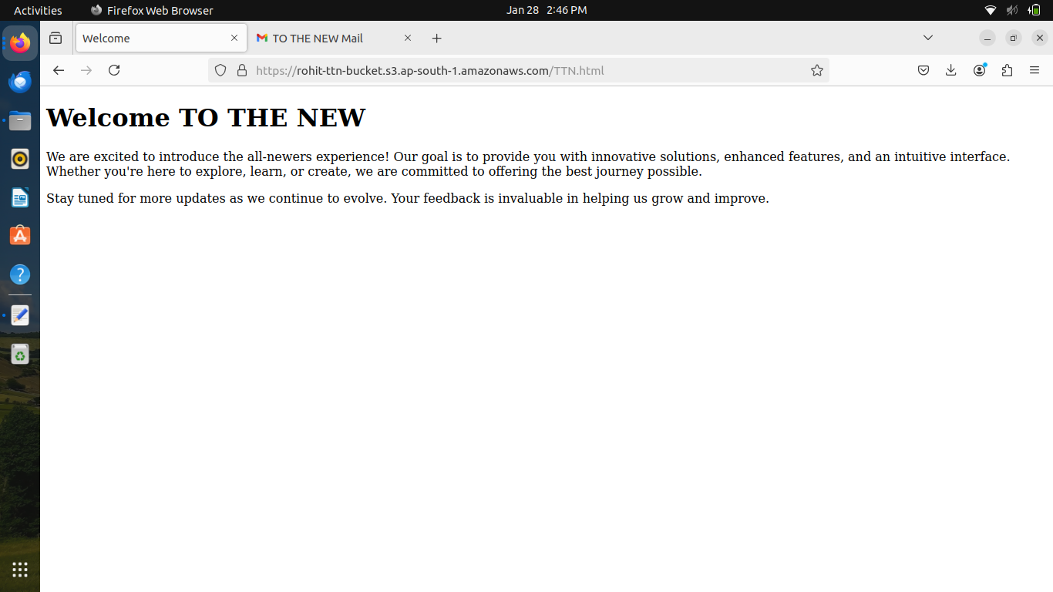

1. Launch an Ubuntu EC2 instance on AWS, with 10GB root volume, and SSH from your local machine using the private key.

###### **Create an Ubuntu Amazon EC2 instance**

1. **Choose Launch Instance.**

* Name – Type a name for the instance.
* Application and OS Images (Amazon Machine Image) – Select **Ubuntu**.
* Instance type – Select **t2.micro.**
* Key pair login – Create your own key pair.
* Network settings – Keep the default.
* Configure storage – Increase the volume to 10GB.
* Click on Launch Instance Button.

1. **Launch the instance and SSH into it.**

* Select **Instances** in the left navigation, then select the instance ID.
* Choose **Connect** in the top-right.
* Choose **SSH client** and follow the instructions on the screen.
* Copy the example command shown.
* Open a terminal and navigate to the downloaded .pem file (likely in ~/Downloads).
* Run the copied command in your terminal to connect to your EC2 instance

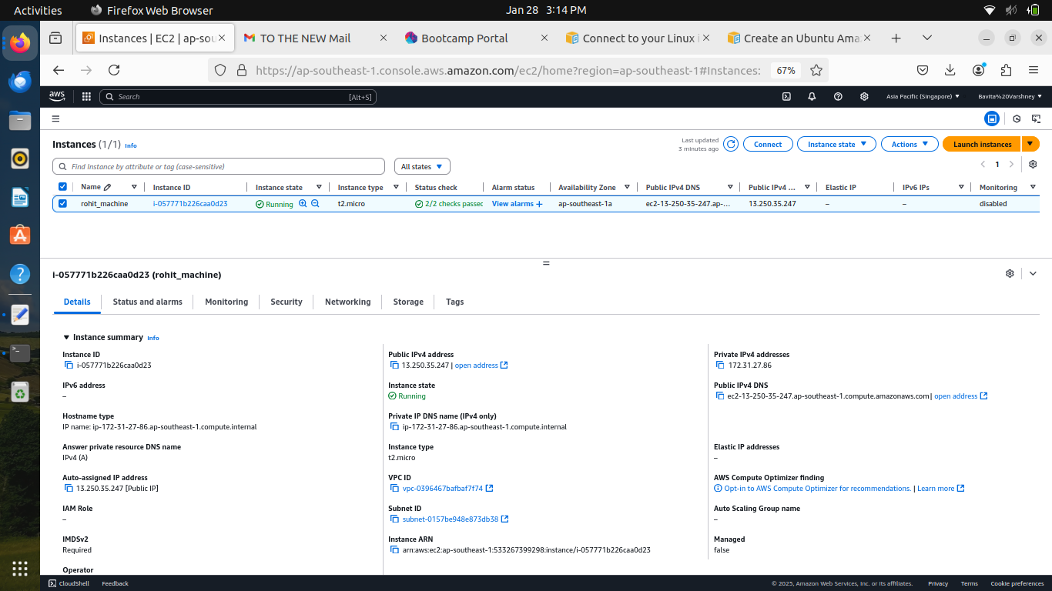

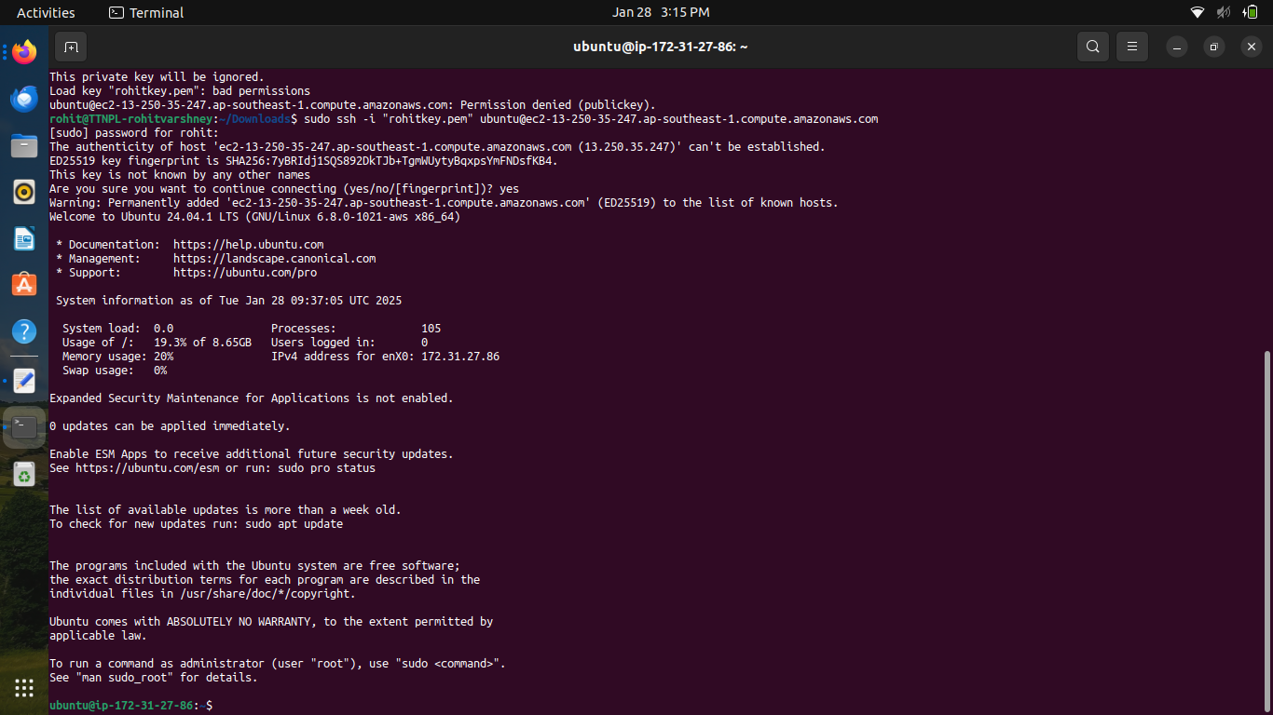

1. Install nginx package in the above server and access this page from your local browser using a domain name instead of IP address of the server.

